Kids today: Changes in school readiness in an early childhood era

Daphna Bassok

University of Virginia

Scott Latham

University of Virginia

Abstract

Public investment in early childhood education has expanded dramatically in recent years. Despite this investment, we have little empirical evidence on whether children today enter school with different skills than they did in the late nineties. Using two large, nationally representative datasets, this paper documents how students entering kindergarten in 2010 compare to those who entered in 1998 in terms of their teacher-reported math, literacy and behavioral skills. Our results indicate that students in the more recent cohort entered kindergarten substantially more proficient at both math and literacy skills. Increases in academic skills over this period were particularly pronounced among black children. Implications for policy are discussed.

*Keywords:* school readiness, achievement, early childhood, student cognition

**Kids today: Changes in school-readiness in an early childhood era**

Over the past two decades, public investment in early childhood education has grown rapidly. Between 2001 and 2014 state spending on preschool initiatives more than doubled from $2.4 to $5.6 billion and since the early nineties the number of children in public preschool has also nearly doubled (Barnett, Carolan, Squires, Clarke Brown, & Horowitz, 2015; U.S. Census Bureau, 2015). Many states have recently introduced early learning standards, more restrictive quality regulations for early childhood education providers, and Quality Rating and Improvement Systems (QRIS), accountability systems that incentivize quality improvements in early childhood settings (The Build Initiative & Child Trends, 2015).

Despite the unprecedented interest and investment in early education, we have little empirical evidence on whether children entering kindergarten in recent years have stronger math and literacy skills at school entry than they did in the past, and relatedly whether their behavioral skills have changed. Although datasets like the National Assessment of Educational Progress (NAEP) have long allowed for comparisons over time in the academic achievement of elementary, middle and high school aged students, until now we have had no national data that would allow for comparisons across cohorts of children at kindergarten entry. The current paper aims to fill this gap.

Using two nationally representative samples of children entering kindergarten in

1998 and 2010 this paper asks three related research questions:

1. To what extent do children who entered kindergarten in 2010 differ from those who entered school in 1998 with respect to teacher-reported measures of math, literacy & behavior?
2. Do changes in demographic characteristics, preschool participation and other observable factors over this period explain observed changes in school readiness?
3. Do changes in school readiness over time differ across racial and socio-economic subgroups leading to changes in school-entry achievement gaps?

**Background**

Some research indicates that children’s early academic skills are strongly predictive of outcomes well into the future, including college attendance, home ownership, earnings, and retirement savings (Chetty et al., 2011). It is also well documented that by kindergarten entry there are large achievement gaps based on race and income, and that these gaps persist as children proceed through school (Fryer & Levitt, 2004; Reardon, 2011).

Over the past three decades a large body of evidence from education, developmental psychology, neuroscience, and economics has demonstrated that early childhood is a particularly malleable time in the life course and that interventions targeted towards this period can have both long-lasting and cost-effective impacts (Bassok & Loeb, 2015; Heckman, 2006; Shonkoff & Phillips, 2000). Bioecological theory suggests that optimal development occurs when children experience consistent and supportive interactions with the people and objects in their immediate environment (Bronfenbrenner, 1979; Bronfenbrenner & Morris, 2006). By providing a stimulating and enriching environment for children in the years before kindergarten, early interventions can potentially prevent gaps from developing, or mitigate their severity. Indeed, a large body of evidence suggests early childhood programs can have important short- and long-term benefits (Camilli, Vargas, Ryan, & Barnett, 2010; Campbell et al., 2012; Deming, 2009; Schweinhart et al., 2005; Weiland & Yoshikawa, 2013).

Growing understanding of both the importance of early childhood in the life course *and* the documented benefits of high-quality preschool interventions has led to a sharp increase in public support for early childhood opportunities. One plausible, though untested, hypothesis is that the rapid expansion of public preschool since the late nineties has led to an improvement in children’s “school readiness” broadly defined.

The limited existing evidence does support the notion that children are entering schools more “ready” than they once were. Using repeated, nationally representative surveys of parents with children ages 3-6, a recent report showed that between 1993 and 2012, the percentage of parents who said their child could recognize all the letters in the alphabet nearly doubled from 21 to 38 percent (Child Trends, 2015). Similarly, the percentage of parents that indicated their children could count to 20 increased by 16 percentage points. Although that study relied solely on parent reports of four relatively crude measures of children’s school readiness skills, the findings suggest that young children acquire basic academic skills at an earlier age than they once did.

Similarly, three states that have been conducting school readiness assessments for over a decade recently released reports that indicate children are increasingly arriving at kindergarten “ready to learn” based on assessments at school entry (Maryland State Department of Education, 2014; Minnesota Department of Education, 2013; Virginia Performs, 2015).

While these trends are aligned with our hypothesis, to date there has not been a systematic empirical study documenting national changes in school readiness over time. This is the primary goal of the current study. In addition, we examine whether changes in school readiness over time have differed across groups of children. Because the majority of public early childhood programs are targeted towards low-income students (Barnett et al 2015) we might expect that improvements in children’s academic skills at kindergarten entry would be particularly pronounced among low-income and minority children. Consistent with this hypothesis, recent work by Reardon & Portilla (2015) demonstrates that between 1998 and 2010 racial and income-based gaps in reading and math scores at school entry have narrowed. Note, however, that the narrowing achievement *gaps* documented tell us nothing about changes in the *levels* of academic skills at school entry (i.e. gaps could narrow even if average school readiness skills have dropped or stayed the same). In the current study we explore whether non-white and poor children experienced greater changes in academic outcomes than did their peers.

Finally, the current study adds to the existing literature by documenting national trends in children’s behavioral skills at school entry. It is difficult to provide directional hypotheses about changes over time in children’s behavior. On one hand, if more children are experiencing preschool in the year prior to kindergarten, perhaps they enter kindergarten more prepared to meet classroom norms and behavioral expectations. On the other hand, research demonstrates that preschool participation is negatively associated behavioral outcomes in subsequent years (Belsky et al., 2007; Loeb, Bridges, Bassok, Fuller, & Rumberger, 2007). Researchers have also hypothesized that exposure to structured literacy or math curriculum in early childhood may be associated with stress, problem behaviors or other unintended behavioral consequences (Christakis, 2016; Stipek et al., 1998; Stipek, Feiler, Daniels, & Milburn, 1995). We provide descriptive evidence to address these hypotheses.

**Method**

**Data**

The National Center for Education Statistics (NCES) has tracked two large, nationally representative cohorts of children longitudinally starting in kindergarten through its Early Childhood Longitudinal Study (ECLS) program. The first cohort began kindergarten in 1998 and the second started in 2010.1 Because the studies provide largely overlapping and comparable measures (West, Denton, & Germino-Hausken, 2000; West, Denton, & Reaney, 2001), the combined datasets provide a unique opportunity to assess whether there have been nationwide changes in school readiness, both for the overall population and for specific subgroups, over a period characterized by heightened investment in early childhood.

Each dataset was collected using a multi-stage probability sample design; children were selected from schools which were first selected from “primary sampling units” (counties or groups of counties). Schools and primary sampling units were both chosen with probability proportional to size. Both datasets include direct student assessments of children as well as parent and teacher surveys in the fall and spring of the kindergarten year, and a school administrator survey in the spring (Tourangeau, Nord, Lê, Sorongon, & Najarian, 2009). The original ECLS-K followed students through 8th grade, and the 2010 cohort will be followed through fifth grade. We limit our analysis to first-time kindergarteners in each cohort. We limit our sample to observations with non-missing data for all outcomes considered, and construct two separate samples when considering academic and behavioral outcomes. The academic sample includes approximately 16,050 students in 1998 and 13,500 in 2010, and the behavioral sample includes approximately 14,750 and 11,900 students in 1998 and 2010 respectively (all sample sizes rounded to the nearest 50 in accordance with NCES guidelines).

We conduct multiple imputation using chained equations to avoid the bias that may arise when analyzing complete-case data. Our imputation model accounts for all the covariates that we later include in our analysis (i.e. demographics, home environment, and kindergarten teacher characteristics), and we impute independent but not dependent variables. Multiple imputation was conducted using the MI command in Stata, and following Allison (2012) 20 imputed datasets were generated.

**Measures of school readiness.** The ECLS-K datasets contain multiple potential measures of children’s school readiness including direct assessments and teacher-reported measures of early literacy and mathematics knowledge, as well as teacher-reported measures of children’s behavior.

***Teacher-reported measures.*** Ideally, to analyze changes in students’ math and literacy ability over time we would compare direct assessments across the two cohorts. Although both ECLS-K waves directly assessed students’ math and literacy ability, these assessments are not directly comparable across the two cohorts (Tourangeau et al., 2013). As a result, this analysis relies on teacher-reported measures of student skills at kindergarten entry.

Existing research demonstrates that teachers’ assessments of students’ cognitive skills are strongly correlated with both current and future direct assessments (Hecht & Greenfield, 2001; Hoge & Coladarci, 1989; Teisl, Mazzocco, & Myers, 2001). This pattern certainly holds in both waves of the ECLS-K as shown in Appendix A. The table also highlights that for the earlier cohort, teacher-reported measures of children’s early readiness skills are predictive of direct assessments not only in kindergarten but all the way through eighth grade.

Despite the strong correlation between teacher reports and direct assessments, caution is warranted when using teacher assessments to measure children’s “true” ability. Earlier studies have shown that a portion of the variation in teacher assessments of young children is explained by both teacher characteristics (e.g. education levels, experience) and child characteristics (e.g. race, socio-economic status (SES)) (Kilday, Kinzie, Mashburn, & Whittaker, 2012; Mashburn, Hamre, Downer, & Pianta, 2006). Despite this, teacher assessments are the most widely-used, cost-effective and efficient method for assessing young children. In fact, teachers’ extensive interactions with children may allow them unique insights and knowledge not captured by direct assessments (Epstein, Schweinhart, DeBruin-Parecki, & Robin, 2004).

A further concern when using teacher assessments to track *changes* in children’s skills over time is that observed changes may be driven in part by changes over time in how teachers perceive children or in teacher’s approaches to assessing children. We have no way to definitively assess whether teachers have changed the way they assign ratings over time, an important limitation we return to at the end of the paper.

***Academic outcomes*.** Both ECLS-K datasets include teacher-reported measures of student proficiency across a broad range of math and literacy skills. In the first months of kindergarten (September-December), teachers were asked to rate each child’s proficiency in the following 14 domains on a scale from 1 (“Child has not yet demonstrated skill”) to 5 (“Child demonstrates skill competently and consistently”):2

Math skills

* Sorts math materials by various rules and attributes
* Orders groups of objects (by height, color, etc.)
* Understands relative quantities
* Solves problems using numbers
* Understands graphing activities
* Uses instruments accurately for measuring
* Uses a variety of strategies to solve math problems

Language and literacy skills ("Literacy")

* Uses complex sentence structures
* Understands and interprets stories read to him/her
* Easily names all upper and lower case letters
* Predicts what will happen next in stories
* Reads simple books independently
* Demonstrates early writing behaviors
* Understands conventions of print

We analyze changes in proficiency over time for each individual skill, and also construct three summary measures for each subject. First, to construct measures of students’ overall proficiency in math and literacy, we average across the items within each subject (e.g. the average of 7 math skills is the “overall math” proficiency). Next, for each subject we construct indicator variables labeled “low proficiency” and “high proficiency” to indicate whether students were in the tails of the distribution. Specifically, we define “low proficiency” to mean that a student was rated either a 1 or 2 on at least half of the skills considered, and “high proficiency” to mean that a student was rated either a 4 or 5 on at least half of the skills. For example a student who was rated a 1 or 2 on at least 4 of 7 math skills would be classified as having low math proficiency.

Because teacher assessments were collected during the first few months of kindergarten, they are not “pure” measures of student knowledge at school entry and may be capturing, in part, skills gained during the beginning of the school year. This concern is lessened because the data collection period is extremely similar across the two studies. All of our estimates also control for the amount of time that children spent in kindergarten before assessment.

***Behavioral outcomes*.** In the fall of the kindergarten year, teachers completed a version of the Social Skills Rating System (Gresham & Elliott, 1990), a widely used assessment of social and emotional development, and a scale that measures student approaches to learning. Respondents were asked to rate the frequency of different types of student behavior on a scale from 1 ("Never exhibits behavior") to 4 ("Exhibits behavior frequently"). These items were then combined into “subscales” which capture different dimensions of student behavior. The ECLS-K contains information about five subscales, which we report along with both the number of items and the subscale reliability coefficients. Reliability coefficients were quite similar across cohorts, so we report pooled coefficients here for all subscales except one (approaches to learning), which differed slightly in the number of items across cohorts. The five subscales were self-control (4 items, reliably coefficient (RC) = .85), interpersonal skills (5 items, RC = .88), externalizing problem behavior (5 items, RC = .89), internalizing problem behavior (4 items, RC = .80) and approaches to learning (6 items in 1998, RC = .89; 7 items in 2010, RC = .91).

These behavioral measures have skewed distributions, in that teachers report kindergarteners are generally well-behaved. Following Grimm et al. (2010), we address this issue by dichotomizing behavioral measures to construct indicators of problem behavior. Three of the measures considered indicate positive behavior (i.e. self-control, interpersonal behavior, approaches to learning) and so for these we construct indicators for whether a student was at least 1 SD *below* the 1998 mean. By contrast, for the two outcomes indicating negative behavior (i.e. internalizing and externalizing) we construct indicators for whether a student was at least 1 SD *above* the 1998 mean.

***Early childhood experiences*.** To measure access and exposure to early childhood education we use parent reports of the type of care their children received in the year prior to kindergarten. Specifically, we account for whether a child attended "formal" care (defined as either Head Start, pre-kindergarten or center-based care), whether a child attended a *public* formal careprogram, the number of hours a child spent in formal care each week, and whether a child attended kindergarten and prekindergarten in the same building, a proxy for school-based prekindergarten, which is associated with greater academic benefits for children (Magnuson, Ruhm, & Waldfogel, 2007). We also consider principal reports of whether the child's kindergarten school also offers prekindergarten. Appendix B provides descriptive statistics for these and all other variables included in our analysis, separately by cohort. We do not observe meaningful changes in formal care utilization; about two thirds of children attended formal care in both waves. However, consistent with heightened investments in public preschool, we note substantial increases in publicly-funded preschool and in elementary schools offering kindergarten programs.

***Additional covariates.*** We disaggregate our analysis by race and a measure of SES constructed from parental income, education, and occupational prestige, which we divide into quintiles.

Although this manuscript is motivated by the rapid expansion of public early childhood education opportunities, many other factors changed over the study period, and in a final set of analyses we assess whether changes in three other sets of covariates explain changes in school readiness: demographic characteristics of children and families; children’s home learning environment and parental interactions; and teacher characteristics. A key strength of the ECLS-K datasets is that they provide unusually rich data about these measures.

Because demographic changes may be associated with changes over time in children’s school readiness, we account for age (both at kindergarten entry and at assessment), gender, whether children were born in the U.S., whether they are U.S. citizens, and whether English is the primary language (or spoken at all) in children’s homes. We also account for the region of the country in which children reside. Appendix B highlights changes in these variables over time; most notable is the increase in the percentage of Hispanic kindergarteners. In a recent study, Bassok et al. (2016) use the same ECLS datasets leveraged in the current study to examine changes over time in early childhood experiences . That analysis showed substantial increases in the time parents spent engaging with their children, the amount of learning materials children had in the home (e.g. books, educational computer games), and the expectations parents held about school readiness. Further, many of these measures increased disproportionately among low-income children.

These changes may have had meaningful implications for children’s school readiness and to address this we include a host of measures of children’s home environments. Parents were asked about the frequency with which they do activities with their children, such as reading books, playing games, and doing chores. Parents were also asked to rate the extent to which they think a number of skills are important for school readiness. These skills include counting to 20, knowing the letters of the alphabet, sharing with others, using a pencil, paying attention/sitting still, and communicating needs/wants verbally. Parents were also asked a series of questions regarding their child’s use of computers in the home. They were asked whether their child uses a computer, how frequently, and whether the child uses the computer to access the internet and for educational purposes. Appendix B highlights systematic increases across many of these measures.

Finally, kindergarten teachers reported detailed information about their demographics, teaching experience, and education. We include these measures because earlier studies have highlighted the association between teacher characteristics and their assessments of child outcomes in early childhood settings (Mashburn et al., 2006).

**Analysis**

We compare measures of school readiness over time using Ordinary Least Squares (OLS) (and Linear Probability Models for the dichotomous outcome variables).3 To describe changes over time in these measures, we specify the following model:

yi = β0 + β1ECLS2010i + β2Agei  + εi (0)

Here, *yi* refers to either an academic or behavioral outcome for student *i*, and *ECLS2010i* is an indicator set to 1 if student *i* was part of the 2010 ECLS-K cohort, and set to 0 if the student was part of the 1998 cohort. *Agei* represents student *i*’s age in months both at kindergarten entry and at the time of assessment. This controls for potential differences in age across cohorts that may be confounded with differences in cognitive and social abilities, as well as differences in timing of assessments across cohorts. *εi* represents an error term with mean 0. *β1*is the coefficient of interest, and it provides an estimate of the (age-adjusted) difference across cohorts for each outcome variable. We also employ probability weights that adjust for non-response, making the results nationally representative. Standard errors are clustered at the teacher level.

After describing the raw magnitude of the changes over time, we explore how the results change when accounting for changes in demographics across this time. Here, we estimate the following model:

yi = β0 + β1ECLS2010i + β2Agei + β3Demographicsi’ + εi (1)

where *Demographicsi’* is a vector that includes race, SES, ELL status, and whether the child is U.S. born or a U.S. citizen. We use β1 from model (1) as the starting point from which we will try to account for differences across cohorts using observable measures of preschool attendance, the home environment, and kindergarten teacher characteristics. Here, we estimate the following series of models:

yi = β0 + β1ECLS2010i + β2Agei + β3Demographicsi’ + β4Preschooli’ + εi (2)

yi = β0 + β1ECLS2010i + β2Agei + β3Demographicsi’ + β4Preschooli’ (3)

+ β5Home_envi + β6K_tch_charsi’ + εi

Here, *Preschooli’* is a vector that includes variables relating to preschool care in the year before kindergarten. *Home_envi’* is a vector that includes parent beliefs about the importance of different skills for kindergarten readiness, activities in which the child participates, and measures of computer availability and use. *K_tch_charsi’* includes information about kindergarten teachers’ background and qualifications. To the extent that we find differences in β1 between model (1) and models (2) or (3), this would suggest that changes in student outcomes were explained, at least partly, by the included covariates. Finally, we examine whether differences in student outcomes across cohorts vary by race and socioeconomic status. Here, we estimate models of the form:

yi = β0 + β1ECLS2010i + β2Agei + β3Racei’ + β4ECLS2010i * Racei’ + εi (4)

yi = β0 + β1ECLS2010i + β2Agei + β3SESQ1i + β4ECLS2010i * SESQ1i + εi (5)

In model (4), *Racei’* includes indicators for whether a student is black, Hispanic, Asian, or other nonwhite (omitting white). These indicators are then each interacted with the 2010 cohort to explore whether there were disproportionate changes over time for students of differing race/ethnicity. In model (5), we include an indicator for whether a student was in the lowest SES quintile (i.e. the poorest children), and also interact that indicator with the 2010 cohort, to explore whether there were disproportionate changes among the lowest income students. Across both models, the coefficients of interest are the β4s, which estimate the extent to which differences in school readiness between cohorts differed by race and SES. These coefficients can be interpreted as changes in school readiness relative to white students and students in the top four SES quintiles, respectively.

**Results**

**Changes in academic skills at school-entry**

Figure 1 presents the distribution for four sample measures of kindergarten readiness (e.g. reads simple books independently, understands relative quantity). The grey bars show the distribution of these skills in 1998 and the unshaded bars show the distribution in 2010. In all cases we observe the distribution shifting to the right, indicating that in 2010 teachers reported stronger academic skills for their incoming kindergarteners relative to 1998. The pattern is particularly pronounced for letter recognition. In 1998, approximately a quarter of children were rated by their teacher as “not yet” demonstrating that skill, and 15 percent were demonstrated the skill consistently. By 2010 the distribution reversed, with only 15 percent entering not yet recognizing letters and 25 percent doing so consistently. Appendix C shows similar figures for all the literacy and math outcomes considered, and shows that to varying degrees this pattern is consistent across all items considered.

In Table 1 - Panel A we present changes over the period in our measures of math and literacy proficiency. Model 0 shows results that control only for student age at kindergarten entry and at assessment, and thus addresses our first research question about “raw” changes in school readiness over time. These results mirror the patterns we see in Figure 1. Strikingly, students in the 2010 cohort were rated about .25 standard deviations (SD) higher on both math and literacy skills than their 1998 counterparts. Changes were apparent throughout the ability distribution; in both math and literacy we see drops in the percentage of children who were classified as “low proficiency” and increases in the percent that are labeled “high proficiency”.

Next we assess to the extent to which these changes are explained by observable covariates. Controlling for demographic characteristics (Model 1), does not explain away the changes over time; rather, differences across cohorts are slightly larger in these models. Counter to our expectations, including measures of preschool participation (Model 2) does not account for *any* of the differences across time for either math or literacy. Adding a rich set of controls for home environment and kindergarten teacher characteristics (Model 3) accounts for roughly 1/5 to 1/3 of the differences across cohorts.

**Changes in behavior at school entry**

Table 1 - Panel B shows changes in teacher-reported behavioral measures over time. Here, we find no overall changes over time on self-control, interpersonal skills or externalizing problem behaviors). However, teachers reported that children in 2010 showed poorer approaches to learning, which measures children’s ability to pay attention or adapt to changes in routines. Conversely, they reported that children in the more recent cohort were less likely to demonstrate internalizing problem behaviors, which measure children’s shyness or loneliness. Including an increasingly rich set of covariates does not explain any of these differences over time.

**Differences in patterns by race and socio-economic status**

Figure 2 shows how teacher-reported math proficiency changed over time disaggregated by race and SES. We present the percentage of children that were low proficiency and high proficiency in each cohort. Appendix D provides an analogous figure for literacy. A few patterns emerge. First, across both math and literacy, we see that white children are rated as having higher kindergarten readiness skills relative to black and Hispanic children (i.e. more children are classified as “high proficiency” and fewer as “low proficiency”), and similarly that children in the top four quintiles of SES are rated substantially higher than those in the bottom quintile.

The figures also indicate that teachers ranked *all* groups higher in 2010 than in 1998. For all subgroups considered we see drops in the percentage of children at the bottom and increases in the percentage of children at the top. Notably, the overall changes shown in this figure are more pronounced among black children than among other groups. For example, while the percentage of white children who demonstrated low proficiency in math dropped by about 8 percentage points over this period, the same percentage of black children dropped by 15 percentage points, almost double. Conversely, the percentage of white children who were classified as high proficiency in math increased by 9 percentage points from 1998 to 2010, and the corresponding increase for black students was 13 percentage points.

In Table 2 we formally examine differences in math and literacy proficiency across subgroups within a regression framework. The top panel explores how changes differ by race/ethnicity. These findings mirror those from Figure 2. In particular, while all children experienced increases over this time, the magnitude of changes for black children was disproportionately larger both in literacy and in math, and across each of our summary measures. There is little evidence of disproportionate changes among Hispanic students, though they did improve on math at a marginally higher rate relative to white peers.

The bottom panel of Table 2 shows how changes over time in math and literacy proficiency differ for the poorest children. Again, early math and literacy proficiency increased across the board. We do not find much evidence that children in the lowest socioeconomic quintile showed greater gains over this period, though there is marginal evidence of greater growth in this group for math.

**Discussion and Conclusions**

This study provides the first nationally representative examination of changes in children’s school readiness over time across both academic and behavioral measures. We find that children are arriving at school with a different set of skills than they were in the late nineties, as measured by teacher assessments. In particular, children are entering kindergarten more proficient across a variety of math and reading skills. These changes are sizable. One way to think about the magnitude of the changes in academic readiness observed in the current study is relative to the growth observed from the fall to the spring of kindergarten for the 1998 cohort. In 1998 students’ average score on the overall math measure was 2.51 in the fall and 3.62 in the spring. Students in 2010 started kindergarten at an average score of 2.70 in the fall. This suggests that students arriving at kindergarten in 2010 had already learned about 17 percent of what they previously would have learned in kindergarten. For literacy the change is just slightly smaller.

Notably, the changes we observe in the current study were not limited to a single subgroup. We see increases in reading and math readiness across all students regardless of race or SES, and throughout the distribution of school readiness skills. However, we find particularly large gains in math and literacy proficiency among black children, relative to their white peers. We also find modest but suggestive evidence that math skills increased more among Hispanic children and children in the lowest SES quintile, relative to their white and higher SES peers.

These findings are encouraging and suggest a narrowing in the “school readiness” gap. The patterns are largely consistent with recent research that documents narrowing of race and income-based gaps using *direct measures of cognitive skills* (Reardon & Portilla, 2015). Taken together, these studies suggest that since the late nineties early achievement gaps are narrowing and *simultaneously* that the skills and knowledge children possess when entering school are increasing.

This is an intriguing result and has important implications for the way we structure children’s early learning experiences. If children are entering kindergarten with a different set of skills than they once were, it is essential that kindergarten teachers are responsive to these changes. Recent work suggests that there is misalignment between children’s skills at school entry and the type of instruction they receive in kindergarten, with children spending too much time on skills they already know (Engel, Claessens, & Finch, 2013). Note that our findings do not imply that kindergarten needs to get more demanding or challenging. Rather, there is a need to better understand what skills children already have at school entry, and how kindergarten can support their development both academically and more broadly.

In the current paper we explored whether increased math and literacy skills at kindergarten entry might have come at a cost in the form of worse behavioral outcomes. Our results here are mixed. We find no differences in teacher-reported behavioral outcomes for self-control, interpersonal skills or externalizing behavior and actually document a *reduction* in internalizing problem behavior. Teachers did, however, rate the 2010 cohort somewhat less favorably with respect to their “approaches to learning,” a measure that captures children’s eagerness to learn, along with their ability to work independently, persist in completing tasks, and pay attention.

One potential explanation for this shift is the changing nature of kindergarten classrooms. In 2010, kindergarteners spent far more time using textbooks and worksheets, being assessed using standardized tests, and participating in teacher-directed instruction (Bassok, Latham, & Rorem, 2016). They also had far fewer opportunities for child-selected activities, art, music, and hands-on exploration. Perhaps then, kindergarten in 2010 required higher levels of focus, persistence and attention than the kindergarten classrooms in the earlier period. It is not immediately clear what might be driving the drop in internalizing problem behaviors, or why we observe improvements in one behavioral measure but declines in another.

**Implications & Next Steps**

Our study was motivated by the rapid increase in public investments in early childhood education. We hypothesized that improved access to early childhood learning opportunities has led to improved school readiness, particularly for low-income and minority children. Although we document trends in school readiness consistent with this hypothesis, our measures of preschool participation failed to explain *any* of the observed changes in school readiness. This surprising result was counter to our expectations.

One potential explanation is that the changes we are observing over time are driven by changes in the *quality* of the child care experiences children have, or changes in the academic focus of these settings. There has been substantial public investment in improving quality both by moving children from informal to formal settings, and by investing in quality enhancements across sectors. Unfortunately, the ECLS-K data do not provide any information about quality measures.

The rich ECLS data allowed us to examine the extent to which a host of covariates measuring child and family demographic characteristics, children’s early home environments and kindergarten teacher characteristics explain changes over time in school readiness. When we include all of these covariates we are able to explain about a fifth of the change in math skills and a third of the change in literacy skills. While this is a substantial portion of the change, it raises important questions about what other factors may be driving the increases in school readiness over time. A better understanding of the mechanism driving the observed shifts is essential for understanding how to target new public initiatives or modify existing ones.

More research is also needed to assess whether the changes we observed in teacher-reported outcomes persist as children progress through school, particularly with respect to direct assessments of skills. We cannot fully answer this question until the new ECLS cohort advances through school and a cross-walk is available to make comparisons of the direct assessments across cohorts. That said, we examined whether differences across our two cohorts were still evident at the end of the kindergarten year (results available upon request). We find that differences across cohorts in teacher-rated early academic skills are *even larger* at the end of kindergarten than they are at the beginning. In addition, the increases observed in the current study are largely mirrored in increasing fourth grade reading and math scores on the National Assessment of Educational Progress (U.S. Department of Education, 2013). These patterns, combined with state reports of rising school readiness over time, bolster our confidence that the teacher-reported measures are capturing “true” changes in children’s knowledge at school entry.

Notes:

1 The more recent ECLS-K cohort began collecting data from students in the fall of 2010 but is officially referred to as the ECLS-K 2011. This paper, however, uses data collected in the fall, so the years of the study are more accurately reported as 1998 and 2010

2 We omit students from our analysis if their teachers reported that topics had not yet been introduced in their classrooms because teachers in these cases have not had a chance to assess student proficiency. However, this exclusion could bias our results if these types of students generally were less proficient than students for whom teachers provided ratings. We performed a bounding exercise to explore the extent to which this could be driving our results. For the purposes of this exercise, we assumed that all students who were missing data for a given skill were not proficient at that skill (i.e. that they were the lowest level of proficiency). We then re-ran our analysis and present results in Appendix F. The results for literacy are quite similar to our main results, suggesting that these results are unlikely to suffer from this type of bias. Estimates for differences in math across time are about 60% as large as our main results. Notably, even using this extremely conservative assumption, we find meaningful differences over time in student reading and math abilities.

**3** Some of our outcomes are dichotomous and are thus most appropriately modeled using a limited dependent variable specification. We have estimated logit models for all dichotomous outcomes considered in this paper and the results are strikingly similar to those from the OLS models. As a result, we present OLS estimates to facilitate easier interpretation.

**Bibliography**

Allison, P. (2012). Why You Probably Need More Imputations Than You Think | Statistical Horizons. Retrieved February 11, 2016, from http://statisticalhorizons.com/more-imputations

Barnett, W. S., Carolan, M. E., Squires, J. H., & Brown, K. C. (2014). *The State of Preschool 2013: State Preschool Yearbook*. New Brunswick, New Jersey: National Institute for Early Education Research.

Barnett, W. S., Carolan, M. E., Squires, J. H., Clarke Brown, K., & Horowitz, M. (2015). *The State of Preschool 2014: State preschool yearbook*. New Brunswick, New Jersey: National Institute for Early Education Research.

Bassok, D., Finch, J., Lee, R., Reardon, S. F., & Waldfogel, J. (2016). Socioeconomic Gaps in Early Childhood Experiences, 1998 to 2010. *EdPolicyWorks Working Paper*. Retrieved from http://curry.virginia.edu/uploads/resourceLibrary/38_Gaps_In_Early_Experience.pdf

Bassok, D., Latham, S., & Rorem, A. (2016). Is Kindergarten the New First Grade? *AERA Open*, *2*(1), 2332858415616358. http://doi.org/10.1177/2332858415616358

Bassok, D., & Loeb, S. (2015). Early Childhood and the Achievement Gap. In H. F. Ladd & M. Goertz (Eds.), *Handbook of Research in Education Finance and Policy* (2nd ed.).

Belsky, J., Vandell, D. L., Burchinal, M., Clarke-Stewart, K. A., McCartney, K., Owen, M. T., & The NICHD Early Child Care Research Network. (2007). Are There Long-Term Effects of Early Child Care? *Child Development*, *78*(2), 681–701. http://doi.org/10.1111/j.1467-8624.2007.01021.x

Bronfenbrenner, U. (1979). Contexts of child rearing: Problems and prospects. *American Psychologist*, *34*(10), 844.

Bronfenbrenner, U., & Morris, P. A. (2006). The bioecological model of human development. *Handbook of Child Psychology*. Retrieved from http://onlinelibrary.wiley.com/doi/10.1002/9780470147658.chpsy0114/full

Camilli, G., Vargas, S., Ryan, S., & Barnett, W. S. (2010). Meta-analysis of the effects of early education interventions on cognitive and social development. *The Teachers College Record*, *112*(3). Retrieved from http://www.tcrecord.org/content.asp?contentid=15440

Campbell, F. A., Pungello, E. P., Burchinal, M., Kainz, K., Pan, Y., Wasik, B. H., … Ramey, C. T. (2012). Adult outcomes as a function of an early childhood educational program: an Abecedarian Project follow-up. *Developmental Psychology*, *48*(4), 1033.

Chetty, R., Friedman, J. N., Hilger, N., Saez, E., Schanzenbach, D. W., & Yagan, D. (2011). How Does Your Kindergarten Classroom Affect Your Earnings? Evidence from Project Star. *The Quarterly Journal of Economics*, *126*(4), 1593–1660.

Child Trends. (2015). *Early School Readiness: Indicators on Children and Youth*.

Christakis, E. (2016). *The Importance of Being Little: What Preschoolers Really Need from Grownups*. Penguin.

Deming, D. (2009). Early childhood intervention and life-cycle skill development: Evidence from Head Start. *American Economic Journal: Applied Economics*, 111–134.

Engel, M., Claessens, A., & Finch, M. A. (2013). Teaching Students What They Already Know? The (Mis)Alignment Between Mathematics Instructional Content and Student Knowledge in Kindergarten. *Educational Evaluation and Policy Analysis*, *35*(2), 157–178. http://doi.org/10.3102/0162373712461850

Epstein, A. S., Schweinhart, L. J., DeBruin-Parecki, A., & Robin, K. B. (2004). *Preschool assessment: A guide to developing a balanced approach*. NIEER. Retrieved from http://nieer-www1.rutgers.edu/resources/policybriefs/7.pdf

Fryer, R. G., & Levitt, S. D. (2004). Understanding the Black-White test score gap in the first two years of school. *Review of Economics and Statistics*, *86*(2), 447–464.

Gresham, F. M., & Elliott, S. N. (1990). *Social skills rating system: Manual*. American Guidance Service.

Grimm, K. J., Steele, J. S., Mashburn, A. J., Burchinal, M., & Pianta, R. C. (2010). Early behavioral associations of achievement trajectories. *Developmental Psychology*, *46*(5), 976–983. http://doi.org/10.1037/a0018878

Hecht, S. A., & Greenfield, D. B. (2001). Comparing the predictive validity of first grade teacher ratings and reading-related tests on third grade levels of reading skills in young children exposed to poverty. *School Psychology Review*, *30*(1), 50–69.

Heckman, J. J. (2006). Skill Formation and the Economics of Investing in Disadvantaged Children. *Science*, *312*(5782), 1900–1902.

Hoge, R. D., & Coladarci, T. (1989). Teacher-Based Judgments of Academic Achievement: A Review of Literature. *Review of Educational Research*, *59*(3), 297–313. http://doi.org/10.3102/00346543059003297

Kilday, C. R., Kinzie, M. B., Mashburn, A. J., & Whittaker, J. V. (2012). Accuracy of Teacher Judgments of Preschoolers’ Math Skills. *Journal of Psychoeducational Assessment*, *30*(2), 148–159. http://doi.org/10.1177/0734282911412722

Loeb, S., Bridges, M., Bassok, Fuller, B., & Rumberger, R. (2007). How much is too much? The influence of preschool centers on children’s social and cognitive development. *Economics of Education Review*, *26*(1), 52–66.

Magnuson, K. A., Ruhm, C., & Waldfogel, J. (2007). Does prekindergarten improve school preparation and performance? *Economics of Education Review*, *26*(1), 33–51.

Maryland State Department of Education. (2014). *Getting Ready: The 2013-2014 Maryland School Readiness Report*. Baltimore, Maryland.

Mashburn, A. J., Hamre, B. K., Downer, J. T., & Pianta, R. C. (2006). Teacher and Classroom Characteristics Associated With Teachers’ Ratings of Prekindergartners’ Relationships and Behaviors. *Journal of Psychoeducational Assessment*, *24*(4), 367–380. http://doi.org/10.1177/0734282906290594

Minnesota Department of Education. (2013). *Minnesota School Readiness Study: Developmental Assessment at Kindergarten Entrance*.

Reardon, S. F. (2011). The widening academic achievement gap between the rich and the poor: New evidence and possible explanations. In G. J. Duncan & R. J. Murnane (Eds.), *Whither opportunity? Rising inequality, schools and children’s life chances* (pp. 91–116). New York, NY: Russell Sage Foundation.

Reardon, S. F., & Portilla, X. A. (2015). *Recent Trends in Socioeconomic and Racial School Readiness Gaps at Kindergarten Entry*. Stanford, California: Center for Education Policy Analysis. Retrieved from http://cepa.stanford.edu/sites/default/files/reardon%20portilla%20school%20readiness%20gap%20trends%2014jan2015.pdf

Schweinhart, L., Montie, J., Xiang, Z., Barnett, W. S., Belfield, C. R., & Nores, M. (2005). *Lifetime effects: The High/Scope Perry preschool study through age 40*. Ypsilanti: High Scope Press.

Shonkoff, J. P., & Phillips, D. (2000). *From neurons to neighborhoods: The science of early childhood development*. Washington, DC: National Academy Press.

Stipek, D., Feiler, R., Byler, P., Ryan, R., Milburn, S., & Salmon, J. M. (1998). Good Beginnings: What difference does the program make in preparing young children for school? *Journal of Applied Developmental Psychology*, *19*(1), 41–66. http://doi.org/10.1016/S0193-3973(99)80027-6

Stipek, D., Feiler, R., Daniels, D., & Milburn, S. (1995). Effects of Different Instructional Approaches on Young Children’s Achievement and Motivation. *Child Development*, *66*(1), 209–223. http://doi.org/10.1111/j.1467-8624.1995.tb00866.x

Teisl, J. T., Mazzocco, M. M. M., & Myers, G. F. (2001). The Utility of Kindergarten Teacher Ratings for Predicting Low Academic Achievement in First Grade. *Journal of Learning Disabilities*, *34*(3), 286–293. http://doi.org/10.1177/002221940103400308

The Build Initiative & Child Trends. (2015). A Catalog and Comparison of Quality Rating and Improvement Systems (QRIS) [Data System]. Retrieved February 10, 2016, from http://qriscompendium.org/

Tourangeau, K., Nord, C., Lê, T., Sorongon, A. G., Hagedorn, M. C., Daly, P., & Najarian, M. (2013). Early Childhood Longitudinal Study, Kindergarten Class of 2010–11 (ECLSK: 2011), User’s Manual for the ECLS-K: 2011 Kindergarten Data File and Electronic Codebook (NCES 2013-061). *US Department of Education. Washington, DC: National Center for Education Statistics*.

Tourangeau, K., Nord, C., Lê, T., Sorongon, A. G., & Najarian, M. (2009). Early Childhood Longitudinal Study, Kindergarten Class of 1998-99 (ECLS-K): Combined User’s Manual for the ECLS-K Eighth-Grade and K-8 Full Sample Data Files and Electronic Codebooks. NCES 2009-004. *National Center for Education Statistics*. Retrieved from http://eric.ed.gov/?id=ED511826

U.S. Census Bureau. (2015). Table A-1. School Enrollment of the Population 3 Years Old and Over, by Level and Control of School, Race, and Hispanic Origin: October 1955 to 2014. Retrieved April 10, 2011, from http://www.census.gov/hhes/school/data/cps/historical/

U.S. Department of Education. (2013). NAEP - Mathematics and Reading 2013. Retrieved February 12, 2016, from http://www.nationsreportcard.gov/reading_math_2013/#/performance-overview

Virginia Performs. (2015, April 16). Assessing School Readiness in Virginia. Retrieved February 10, 2016, from about:reader?url=http%3A%2F%2Fvaperforms.virginia.gov%2Findicators%2Feducation%2FschoolReadiness.php

Weiland, C., & Yoshikawa, H. (2013). Impacts of a Prekindergarten Program on Children’s Mathematics, Language, Literacy, Executive Function, and Emotional Skills. *Child Development*, *84*(6), 2112–2130.

West, J., Denton, K., & Germino-Hausken, E. (2000). America’s Kindergartners: Findings from the Early Childhood Longitudinal Study, Kindergarten Class of 1998-99, Fall 1998. Retrieved from http://eric.ed.gov/?id=ED438089

West, J., Denton, K., & Reaney, L. (2001). The kindergarten year. *Washington, DC: US Department of Education*.

|  |  |  |  |  |  |  |  |  |  |  |
| --- | --- | --- | --- | --- | --- | --- | --- | --- | --- | --- |
| **Table 1. Differences in teacher-rated student outcomes, across cohorts (OLS estimates)** | | | | | | |  |  |  |  |
| Panel A - Math and literacy proficiency | | |  |  |  | Panel B - Behavioral outcomes | |  |  |  |
|  | (0) | (1) | (2) | (3) |  |  | (0) | (1) | (2) | (3) |
| Math |  |  |  |  |  | Poor self control | 0.01* | 0.02* | 0.01 | 0.01 |
| Overall† | 0.25*** | 0.28*** | 0.28*** | 0.23*** |  |  | (0.01) | (0.01) | (0.01) | (0.01) |
|  | (0.02) | (0.02) | (0.02) | (0.02) |  |  |  |  |  |  |
| Low proficiency | -0.10*** | -0.11*** | -0.11*** | -0.09*** |  | Poor interpersonal behavior | -0.01 | -0.01 | -0.01+ | 0.00 |
|  | (0.01) | (0.01) | (0.01) | (0.01) |  |  | (0.01) | (0.01) | (0.01) | (0.01) |
| High proficiency | 0.09*** | 0.10*** | 0.10*** | 0.08*** |  |  |  |  |  |  |
|  | (0.01) | (0.01) | (0.01) | (0.01) |  | Poor approaches to learning | 0.05*** | 0.05*** | 0.05*** | 0.06*** |
| Literacy |  |  |  |  |  |  | (0.01) | (0.01) | (0.01) | (0.01) |
| Overall† | 0.23*** | 0.26*** | 0.26*** | 0.18*** |  |  |  |  |  |  |
|  | (0.02) | (0.02) | (0.02) | (0.02) |  | High externalizing behavior | 0.00 | 0.00 | -0.01 | 0.00 |
| Low proficiency | -0.09*** | -0.10*** | -0.10*** | -0.08*** |  |  | (0.01) | (0.01) | (0.01) | (0.01) |
|  | (0.01) | (0.01) | (0.01) | (0.01) |  |  |  |  |  |  |
| High proficiency | 0.05*** | 0.06*** | 0.06*** | 0.04*** |  | High internalizing behavior | -0.02*** | -0.02*** | -0.02*** | -0.02*** |
|  | (0.01) | (0.01) | (0.01) | (0.01) |  |  | (0.01) | (0.01) | (0.01) | (0.01) |
| N | 29550 | 29550 | 29550 | 29550 |  | N | 26650 | 26650 | 26650 | 26650 |
| Age | X | X | X | X |  | Age | X | X | X | X |
| Demographics |  | X | X | X |  | Demographics |  | X | X | X |
| Preschool variables |  |  | X | X |  | Preschool variables |  |  | X | X |
| Home environment variables | |  |  | X |  | Home environment variables |  |  |  | X |
| Teacher/class characteristics | |  |  | X |  | Teacher/class characteristics |  |  |  | X |
| Note. Each coefficient comes from a separate regression where an outcome was regressed on an indicator for the 2010 cohort. Standard errors are clustered at the teacher level.  †Measure has been standardized to have mean 0 and SD 1.  + p<.1 * *p*<.05 ** *p*<.01 \*\*\**p*<.001 | | | | | | | | | | |

|  |  |  |  |  |  |  |  |
| --- | --- | --- | --- | --- | --- | --- | --- |
| **Table 2. Differences in teacher-rated math and literacy proficiency across cohorts, by race and SES (OLS estimates)** | | | | | | | |
| Panel A. Differences by race | |  |  |  |  |  |  |
|  | Math |  |  |  | Literacy |  |  |
|  | Overall† | Low | High |  | Overall† | Low | High |
| 2010 cohort | 0.22*** | -0.08*** | 0.08*** |  | 0.21*** | -0.08*** | 0.05*** |
|  | (0.03) | (0.01) | (0.01) |  | (0.03) | (0.01) | (0.01) |
| Black*2010 | 0.13* | -0.06** | 0.04+ |  | 0.10* | -0.05* | 0.04* |
|  | (0.05) | (0.02) | (0.02) |  | (0.05) | (0.02) | (0.02) |
| Hispanic*2010 | 0.08+ | -0.03 | 0.00 |  | 0.04 | -0.03 | 0.00 |
|  | (0.04) | (0.02) | (0.02) |  | (0.04) | (0.02) | (0.02) |
| Asian*2010 | 0.08 | -0.02 | 0.01 |  | 0.11 | -0.01 | 0.03 |
|  | (0.09) | (0.04) | (0.03) |  | (0.09) | (0.04) | (0.03) |
| N | 29550 | 29550 | 29550 |  | 29550 | 29550 | 29550 |
| Panel B. Differences by SES | |  |  |  |  |  |  |
|  | Math |  |  |  | Literacy |  |  |
|  | Overall† | Low | High |  | Overall† | Low | High |
| 2010 cohort | 0.24*** | -0.09*** | 0.09*** |  | 0.23*** | -0.08*** | 0.05*** |
|  | (0.03) | (0.01) | (0.01) |  | (0.02) | (0.01) | (0.01) |
| SESQ1*2010 | 0.06+ | -0.02 | 0.00 |  | 0.01 | -0.03 | -0.01 |
|  | (0.04) | (0.02) | (0.01) |  | (0.03) | (0.02) | (0.01) |
| N | 29550 | 29550 | 29550 |  | 29550 | 29550 | 29550 |
| Note. Each coefficient comes from a separate regression where outcomes were regressed on an indicator for the 2010 cohort and interactions between this indicator and either race (omitting white) or the lowest SES quintile (omitting the top four quintiles). Regressions that use race indicators also included "other race" as a category (results not shown). All regressions control for both children's age at kindergarten entry and their age at assessment. Standard errors are clustered at the teacher level. | | | | | | | |
| †Measure has been standardized to have mean 0 and SD 1. | | | | | |  |  |
| + p<.1 * p<.05 ** p<.01 ***p<.001 | |  |  |  |  |  |  |

**Figure 1. Distribution of selected teacher-reported literacy and math skills**

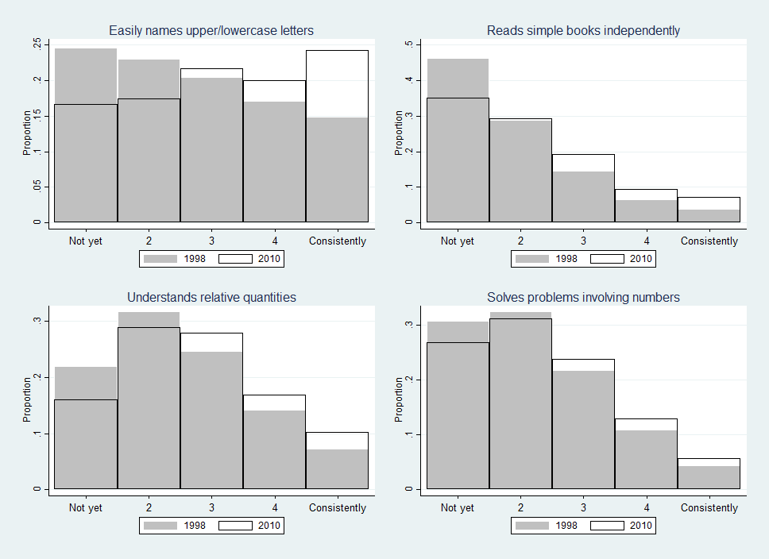

**Figure 2. Percentage of students who were low and high proficiency in math across cohorts**

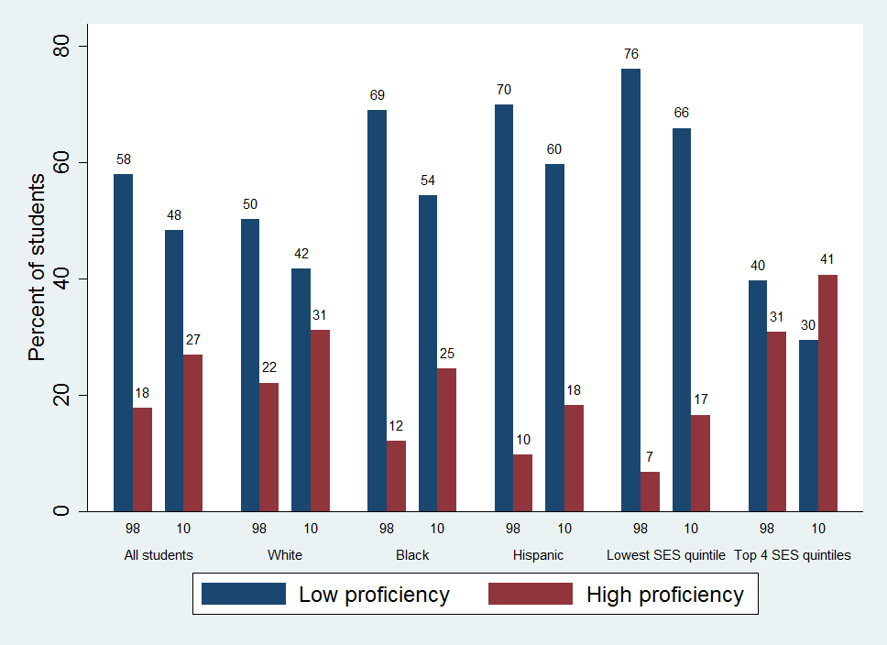

|  |  |  |  |  |  |
| --- | --- | --- | --- | --- | --- |
| **Appendix A. Correlations between teacher-reported measures and direct student assessments** | | | | | |
|  | **Direct assessments** |  |  |  |  |
|  | **ECLS-K 2010** | **ECLS-K 1998** | |  |  |
| Teacher-reported math proficiency | Kindergarten | Kindergarten | 3rd grade | 5th grade | 8th grade |
| Overall | 0.52 | 0.49 | 0.40 | 0.39 | 0.37 |
| High proficiency | 0.38 | 0.33 | 0.26 | 0.25 | 0.24 |
| Low proficiency | -0.42 | -0.39 | -0.34 | -0.33 | -0.31 |
|  |  |  |  |  |  |
| Direct math assessment | - | 1.00 | 0.68 | 0.63 | 0.58 |
| Teacher-reported literacy proficiency | Kindergarten | Kindergarten | 3rd grade | 5th grade | 8th grade |
| Overall | 0.65 | 0.57 | 0.46 | 0.44 | 0.38 |
| High proficiency | 0.48 | 0.43 | 0.33 | 0.31 | 0.27 |
| Low proficiency | -0.50 | -0.43 | -0.38 | -0.36 | -0.31 |
|  |  |  |  |  |  |
| Direct literacy assessment | - | 1.00 | 0.57 | 0.52 | 0.45 |
| Note. Direct assessments were intended to measure broad student ability in math and literacy. These assessments were administered in the fall of the kindergarten year, and in the spring of the 3rd, 5th, and 8th grade years. | | | | | |

|  |  |  |  |  |  |  |  |  |
| --- | --- | --- | --- | --- | --- | --- | --- | --- |
| **Appendix B. Covariate descriptive statistics** | | | |  |  |  |  |  |
|  | 1998 | 2010 |  |  |  | 1998 | 2010 |  |
| *Demographics* |  |  |  |  | *Kindergarten teacher characteristics* |  |  |  | |
| White | 0.58 | 0.52 | *** |  | Male | 0.02 | 0.02 | ** | |
| Black | 0.16 | 0.13 | *** |  | Age | 41.66 | 42.12 | ** | |
| Hispanic | 0.19 | 0.25 | *** |  | White | 0.91 | 0.91 |  | |
| Asian | 0.03 | 0.04 | *** |  | Black | 0.07 | 0.06 |  | |
| Male | 0.51 | 0.51 |  |  | Hispanic | 0.07 | 0.10 | *** | |
| Age in Aug. of kindergarten (months) | 65.76 | 65.96 | *** |  | Asian | 0.02 | 0.02 |  | |
| Speaks language other than English | 0.22 | 0.24 | *** |  | Bachelor's degree (no graduate) | 0.62 | 0.53 | *** | |
| Does not speak English | 0.03 | 0.03 |  |  | Graduate degree | 0.37 | 0.47 | *** | |
| Not U.S. born | 0.03 | 0.03 |  |  | Years teaching kindergarten | 8.99 | 8.72 | *** | |
| Non-citizen | 0.02 | 0.01 |  |  | Years teaching at current school | 9.16 | 9.13 |  | |
| Public school | 0.86 | 0.89 | *** |  | Certified in elementary education | 0.86 | 0.86 | *** | |
|  |  |  |  |  | Certified in Early childhood education | 0.54 | 0.54 | * | |
| *Preschool variables* |  |  |  |  | Took coursework in… |  |  |  | |
| Attended formal pre-k care+ | 0.68 | 0.67 | * |  | Early childhood education | 0.92 | 0.86 | *** | |
| Hrs/wk attended pre-k | 14.66 | 15.56 | *** |  | Elementary education | 0.97 | 0.94 | *** | |
| Attended publicly funded pre-k | 0.28 | 0.45 | *** |  | Special education | 0.72 | 0.72 |  | |
| Attended pre-k/k in same building | 0.12 | 0.17 | *** |  | English as a second language | 0.24 | 0.38 | *** | |
| Attended K in school also offering pre-k | 0.36 | 0.50 | *** |  | Child development | 0.97 | 0.93 | *** | |
|  |  |  |  |  | Methods of teaching reading | 0.98 | 0.95 | *** | |
| *Home environment variables* |  |  |  |  | Methods of teaching math | 0.95 | 0.91 | *** | |
| Proportion of parents rating the following skills "very important" or "essential": | | | | | Methods of teaching science | 0.91 | 0.82 | *** | |
| Knowing most of the letters | 0.69 | 0.82 | *** |  | *Outcome variables* |  |  |  | |
| Counting to 20 | 0.61 | 0.75 | *** |  | Academic |  |  |  | |
| Taking turns/sharing | 0.95 | 0.95 | * |  | Overall math | 2.51 | 2.70 | *** | |
| Using a pencil/paintbrush | 0.73 | 0.83 | *** |  | Low math proficiency | 0.57 | 0.50 | *** | |
| Sitting still/paying attention | 0.84 | 0.86 | *** |  | High math proficiency | 0.19 | 0.26 | *** | |
| Communicating verbally | 0.94 | 0.96 | *** |  | Overall literacy | 2.46 | 2.64 | *** | |
|  |  |  |  |  | Low literacy proficiency | 0.24 | 0.19 | *** | |
| Proportion of parents who report doing the following activities with their children every day: | | | | | High literacy proficiency | 0.22 | 0.25 | *** | |
| Reading books | 0.45 | 0.52 | *** |  | Behavioral |  |  |  | |
| Telling stories | 0.25 | 0.40 | *** |  | Poor self control | 0.15 | 0.17 | ** | |
| Singing songs | 0.45 | 0.45 |  |  | Poor interpersonal behavior | 0.17 | 0.16 |  | |
| Doing chores | 0.53 | 0.52 |  |  | Poor approaches to learning | 0.17 | 0.23 | *** | |
| Playing games | 0.22 | 0.24 | *** |  | High externalizing behavior | 0.13 | 0.13 |  | |
| Talking about nature/science | 0.10 | 0.12 | *** |  | High internalizing behavior | 0.12 | 0.09 | *** | |
| Building something | 0.14 | 0.17 | *** |  |  |  |  |  | |
| Playing sports/exercising | 0.22 | 0.25 | *** |  |  |  |  |  | |
|  |  |  |  |  |  |  |  |  | |
| Computer use |  |  |  |  |  |  |  |  | |
| Child uses computer at home | 0.55 | 0.74 | *** |  |  |  |  |  | |
| Uses computer every day | 0.09 | 0.11 | *** |  |  |  |  |  | |
| Uses computer for educational purposes | 0.49 | 0.64 | *** |  |  |  |  |  | |
| Uses the computer for internet | 0.07 | 0.47 | *** |  |  |  |  |  | |
|  |  |  |  |  |  |  |  |  | |
| +Head Start or Center-based care.  * p <.05, ** p<.01, *** p<.001 | | | |  |  |  |  |  |

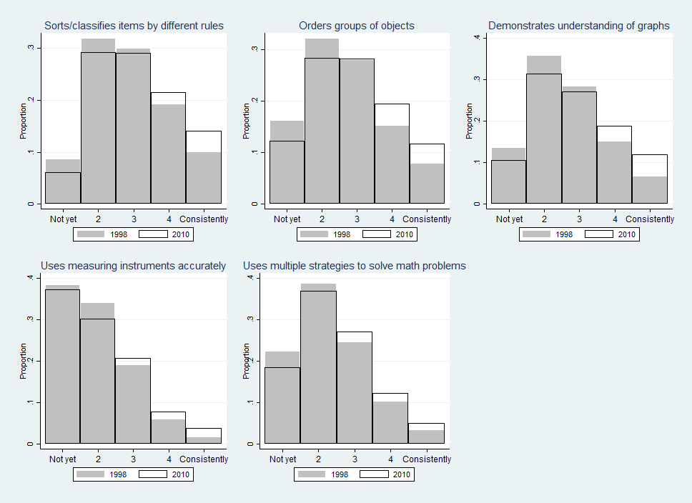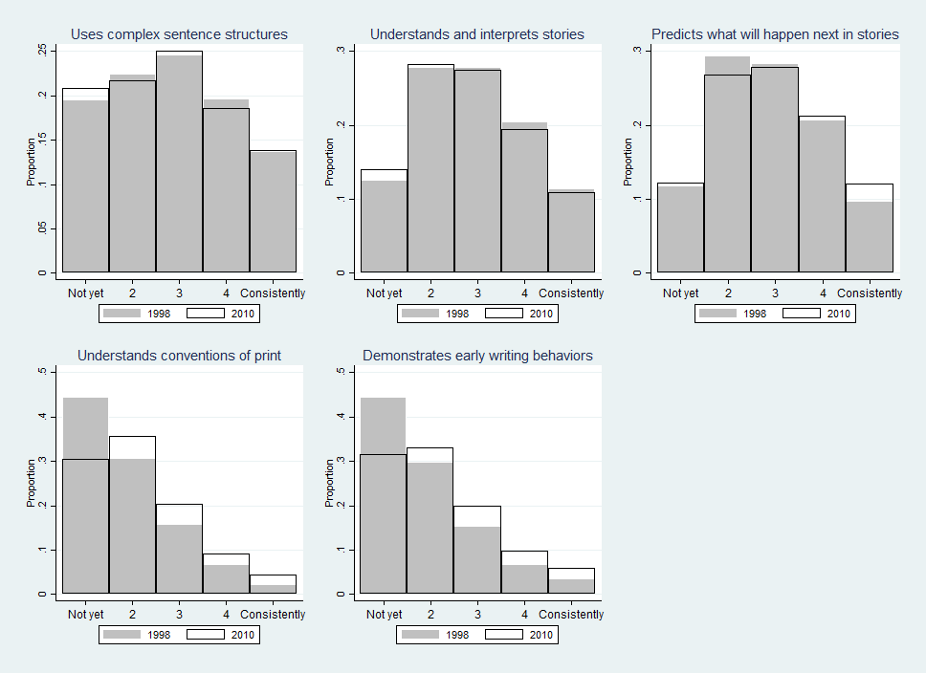**Appendix C. Distribution of additional teacher-reported math and literacy skills**

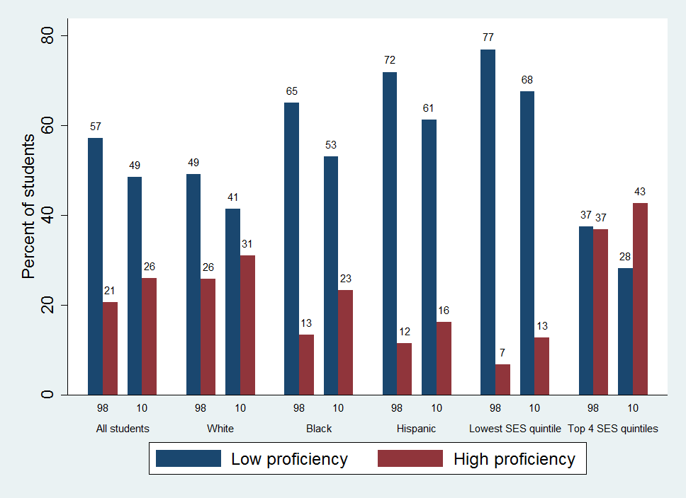**Appendix D. Percentage of students who were low and high proficiency in literacy across cohorts**

|  |  |  |  |  |
| --- | --- | --- | --- | --- |
| **Appendix E. Differences in teacher-rated student proficiency, across cohorts (bounded OLS estimates)** | | | | |
|  | (0) | (1) | (2) | (3) |
| Math |  |  |  |  |
| Overall† | 0.14*** | 0.16*** | 0.16*** | 0.11*** |
|  | (0.02) | (0.02) | (0.02) | (0.02) |
| Low proficiency | -0.07*** | -0.08*** | -0.08*** | -0.06*** |
|  | (0.01) | (0.01) | (0.01) | (0.01) |
| High proficiency | 0.06*** | 0.06*** | 0.06*** | 0.04*** |
|  | (0.01) | (0.01) | (0.01) | (0.01) |
| Literacy |  |  |  |  |
| Overall† | 0.24*** | 0.28*** | 0.28*** | 0.19*** |
|  | (0.02) | (0.02) | (0.02) | (0.02) |
| Low proficiency | -0.10*** | -0.11*** | -0.12*** | -0.09*** |
|  | (0.01) | (0.01) | (0.01) | (0.01) |
| High proficiency | 0.06*** | 0.07*** | 0.07*** | 0.05*** |
|  | (0.01) | (0.01) | (0.01) | (0.01) |
| N | 29550 | 29550 | 29550 | 29550 |
| Age | X | X | X | X |
| Demographics |  | X | X | X |
| Preschool variables |  |  | X | X |
| Home environment variables | |  |  | X |
| Teacher/class characteristics | |  |  | X |
| Note. Each coefficient comes from a separate regression where an outcome was regressed on an indicator for the 2010 cohort. Standard errors are clustered at the teacher level. †Measure has been standardized to have mean 0 and SD 1. +p<.1 * p<.05 ** p<.01 ***p<.001 | | | | |